Saturday, July 4, 2026
7:15 | Bonus Pre-CME Talk
Updates in the Implementation of the Universal Newborn Hearing Screening in the Philippines

Rosario R. Ricalde, M.D.

/ | Disclosure
 | Slides

It is my pleasure to introduce Dr. Rosario “Chit” Ricalde, Director of the Newborn Hearing Screening Reference Center, the technical arm of the Philippine Department of Health responsible for implementing the Universal Newborn Hearing Screening and Intervention Act. Dr. Ricalde is a tenured research faculty member at the National Institutes of Health, University of the Philippines Manila, and a Clinical Professor in the Department of Otolaryngology–Head and Neck Surgery at the UP College of Medicine and Philippine General Hospital. Her expertise includes otology, hearing health in adults and newborns, and vestibular and balance disorders, and she currently serves as Secretary of the Philippine Academy of Neurotology, Otology, and Related Sciences.
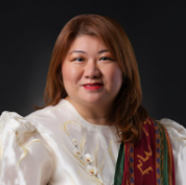

7:45 | Introduction
Moderator: George G.A. Pujalte, M.D.

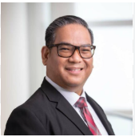

/ | Disclosure

Session 1: Revolutionizing Care: Innovations in Diagnostic and
Therapeutic Technologies

8:00 | Breaking Barriers: Portable HIV Resistance Testing for Every Corner of the Philippines  Edsel Maurice T. Salvana, M.D.  It is my great pleasure to introduce Dr. Edsel Salvaña, one of the Philippines' leading experts in infectious diseases and molecular epidemiology. He serves as Director of the Institute of Molecular Biology and Biotechnology at the University of the Philippines National Institutes of Health, where his research has advanced our understanding of HIV, drug resistance, emerging infectious diseases, and vaccine science. Dr. Salvaña has cared for thousands of patients, helped shape national HIV treatment guidelines, and has been a tireless advocate for evidence-based medicine and public health. His outstanding contributions have been recognized both nationally and internationally, including being named a TED Fellow and TED Senior Fellow. Please join me in warmly welcoming Dr. Salvaña.  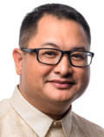  1. Describe recent innovations in diagnostic and therapeutic technologies that are transforming healthcare delivery, with a focus on how portable HIV resistance testing can expand access and improve outcomes in resource-limited settings.  2. Analyze the challenges and opportunities involved in implementing cutting-edge technologies, such as portable diagnostic tools, to overcome geographic, economic, and healthcare system barriers in the Philippines and similar regions.
  / | Disclosure
  / | Slides
8:20 | From Cradle to Community: Then Future of Preventative Pediatric Medicine  Kariktan Cruz, M.D.  It is my pleasure to introduce Dr. Kariktan "Rica" Cruz, a board-certified pediatrician with more than 20 years of experience caring for children and families. She practices at North Bend Medical Center on the Southern Oregon Coast and completed her pediatric residency at Texas Tech University Health Sciences Center. In addition to her expertise in general pediatrics, Dr. Cruz has a special interest in travel medicine and is the region's only certified yellow fever vaccine provider. She is also an active member of the medical community, is fluent in Spanish, and is passionate about global health, international travel, and lifelong learning. Please join me in welcoming Dr. Cruz.  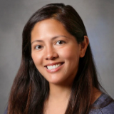  1. Identify emerging diagnostic tools for ADHD, including digital biomarkers, AI-based cognitive testing, and wearable/remote monitoring platforms.  2. Evaluate novel therapeutic technologies, such as digital therapeutics, neurofeedback, and personalized medicine, and how they complement or extend beyond pharmacologic treatment.
  / | Disclosure
  / | Slides
8:40 | Targeted Tomorrow: Research-Driven Innovations Transforming Diagnostics, Therapy, and Precision Medicine  Anna K.P. Serquina, M.D., Ph.D.  It is my pleasure to introduce Dr. Anna "Krista" Serquiña, a physician-scientist and Staff Scientist in the HIV and AIDS Malignancy Branch at the National Cancer Institute's Center for Cancer Research at the National Institutes of Health. She earned her Ph.D. in Gene Function and Expression from the University of Massachusetts Chan Medical School and is dedicated to advancing our understanding of virus-associated cancers. Her research focuses on the molecular mechanisms that drive these cancers and on developing new approaches for their diagnosis and treatment. By bridging clinical medicine and molecular virology, Dr. Serquiña brings a unique and globally informed perspective to cancer research and patient care. Please join me in warmly welcoming Dr. Serquiña.  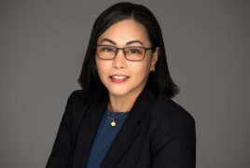  1. Describe how research-driven innovations in diagnostic and therapeutic technologies are revolutionizing patient care and advancing the field of precision medicine.  2. Evaluate the impact of emerging technologies on the future of diagnostics and therapy, with an emphasis on how targeted, research-based approaches are shaping more personalized and effective treatments.
  / | Disclosure
   | Slides
9:00 | The New Rx Revolution: Rethinking Weight, Wellness, and Chronic Disease with GLP-1 Therapies  Kenneth L. Ligaray, M.D.  It is my pleasure to introduce Dr. Kenneth Ligaray, a board-certified endocrinologist with more than 20 years of experience in the care of patients with diabetes, thyroid disorders, and osteoporosis. He practices at UnityPoint Health–Meriter in Madison, Wisconsin, and serves as a Clinical Associate Professor in the Division of Endocrinology, Diabetes, and Metabolism at the University of Wisconsin School of Medicine and Public Health. Dr. Ligaray is widely respected for his patient-centered approach, emphasizing education, compassionate communication, and individualized care to help patients better understand their conditions and achieve long-term health and wellness. Please join me in welcoming Dr. Ligaray.  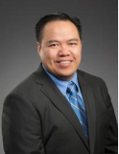  1. Discuss how innovations in diagnostic and therapeutic technologies are reshaping approaches to chronic disease management, including the emerging role of GLP-1 therapies in promoting weight loss and wellness.  2. Analyze the impact of novel therapeutic strategies, such as GLP-1 receptor agonists, within the broader context of revolutionizing care for obesity, diabetes, and other chronic conditions.
  / | Disclosure
  / | Slides
9:20 | Addressing Newborn Hearing Screening Challenges through the Development of Novel Technologies: A Homegrown Newborn Hearing Screening Device  Philip B Fullante, M.D.  Dr. Fullante is an otolaryngologist, biomedical engineer, and innovator whose work centers on developing practical healthcare technologies that enhance patient care and surgical outcomes. He leads initiatives ranging from the development of biomedical devices, including the Kuchi mouth retractor, to advanced point-of-care manufacturing programs that utilize 3D printing to create patient-specific prosthetics through the UP SIBOL Greenhouse and Farm. His research interests encompass newborn hearing screening, cleft care, facial plastic surgery, and craniomaxillofacial surgery, reflecting a strong commitment to advancing innovative, accessible, and patient-centered healthcare solutions.  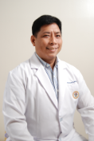  - Describe the latest updates and current challenges in universal newborn hearing screening implement by the Philippine Newborn Hearing Screening Reference Center (NHSRC)  - Present a novel technology designed by Filipinos in collaboration with experts from the University of California Berkley and University of California San Francisco to address the challenges in a resource-challenged environment
9:40 | Q&A Panel
10:00 | Exhibit Hall / Break
Moderator: Jennifer Co-Vu, M.D.

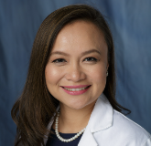

Disclosure

Session 2: Shaping Health Ahead: The Future of Preventive and
Personalized Medicine

10:30 | Mind, Mobility, Medication, and What Matters most : The 4 M Framework of Personalizing Geriatric Care  Diana J. Galindo, M.D.  It is my pleasure to introduce Dr. Diana Galindo, a nationally recognized geriatrician and internal medicine specialist at Cleveland Clinic Florida. She serves as Director of the Center for Geriatric Medicine and previously led the institution's Geriatrics Fellowship Program. For more than 40 years, Dr. Galindo has dedicated her career to improving the health and quality of life of older adults. In addition to her outstanding clinical leadership, she is an accomplished educator, a Past President of the American Medical Women's Association, and has held faculty appointments at both the University of Miami Miller School of Medicine and Florida Atlantic University, where she continues to mentor the next generation of physicians. Please join me in giving a warm welcome to Dr. Galindo.  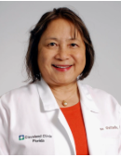  1. Discuss how to personalize geriatric care through the 4 M framework of Geriatric Medicine.  2. Address the evidence-based approach to promoting healthier aging.
  / | Disclosure
  / | Slides
10:50 | Tomorrow’s Cure Today: The Transformative Promise of Gene Therapy  Feorillo Galivo, M.D., Ph.D.  It is my pleasure to introduce Dr. Feorillo Galivo, a physician-scientist, virologist, and Health Scientist Administrator at the National Institute of Allergy and Infectious Diseases at the National Institutes of Health. Dr. Galivo earned his Ph.D. in Virology and Gene Therapy from the Mayo Clinic in Rochester, Minnesota. His research has advanced the fields of gene and cell therapy, genetic reprogramming, oncolytic virotherapy, and cancer immunotherapy. Before joining the NIH, he served as a regulatory scientist at the U.S. Food and Drug Administration, where he reviewed cell and gene therapy products for a wide range of clinical applications. Today, he oversees NIH-supported clinical research in virology, helping translate scientific discoveries into innovative strategies for the prevention and treatment of viral diseases. Please join me in welcoming Dr. Galivo.  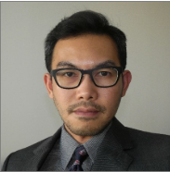  1. Review the current landscape of gene therapy, including approved therapies, mechanisms of action, and key clinical indications, to help general practitioners and specialists recognize where these treatments are beginning to influence routine patient care.  2. Discuss the future role of gene therapy in personalized and preventive medicine, including its potential benefits, limitations, safety considerations, and ethical challenges, to support clinicians in identifying appropriate patients and engaging in informed interdisciplinary care discussions.
  / | Disclosure
  / | Slides
11:10 | Beyond the Stethoscope: Pranic Healing and Mindfulness in Contemporary Medicine  Glenn Mendoza, M.D.  It is my pleasure to introduce Dr. Glenn Mendoza, a physician, educator, author, and internationally respected leader in Pranic Healing and meditation. For more than 35 years, Dr. Mendoza has served as a Neonatal Intensive Care Unit Director while also becoming one of only eight Master Pranic Healers in the world. He leads Pranic Healing meditations, teacher training, and certification programs internationally, and during the COVID-19 pandemic, he organized global healing groups that provided more than 450,000 healing sessions. He also founded the New Hope, New Life program, an adjunct Pranic Healing initiative for patients with cancer. Through his teaching, mentorship, and writings on leadership, spirituality, and personal growth, Dr. Mendoza has inspired people around the world. Please join me in warmly welcoming Dr. Mendoza.    1. Attendees will be able to explain the basic principles of pranic jealing and mindfulness, and discuss how these practices align with holistic approaches to patient care and physician well-being.  2. Attendees will learn to incorporate mindfulness strategies into their daily routines and clinical interactions, fostering emotional resilience, empathy, and improved focus during patient care and academic training.
  Disclosure
  Slides
11:30 | Next-Generation Sleep Care: From Precision Diagnostics to Personalized Therapy  Ninotchka L. Sigua, M.D.  It is my pleasure to introduce Dr. Ninotchka "Notch" Sigua, Associate Professor of Clinical Medicine at the Indiana University School of Medicine and Staff Physician at the Richard L. Roudebush VA Medical Center. After completing her residency and chief residency at Rush University, Dr. Sigua pursued fellowship training in Pulmonary and Critical Care Medicine and Sleep Medicine. She is a recognized leader in sleep medicine, having established Indiana's first hypoglossal nerve stimulator program and pioneered the state's first transvenous phrenic nerve stimulator program for the treatment of sleep apnea. In addition to her clinical work, she is actively involved with the American Academy of Sleep Medicine and the American Thoracic Society and serves as a core faculty member of the Indiana University Sleep Medicine Fellowship Program. Please join me in welcoming Dr. Sigua.  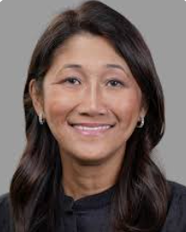  1. Review emerging innovations in sleep medicine, including artificial intelligence, wearable technologies, precision medicine, and digital health platforms, and discuss their role in the diagnosis and monitoring of sleep disorders.  2. Evaluate evolving treatment approaches and future trends in sleep medicine, including technology-enabled care models and data-driven management strategies for sleep disorders.
  / | Disclosure
   | Slides
11:50 | Q&A Panel
12:10 PM | Lunch / Exhibit Hall / Adjourn General Session

Sunday, July 5, 2026
6:30 AM | Mass
7:30 | Continental Breakfast / Exhibit Hall
7:45 | Introduction
Moderator: George G.A. Pujalte, M.D.
Session 3: Reimagining Healthcare Delivery and Access: Building a
Smarter, Fairer Future
8:00 | Advances in Congenital Heart Defect Care: Expanding Access and Enhancing Outcomes  Ernerio T. Alboliras, M.D.  It is my pleasure to introduce Dr. Ernie Alboliras, one of our Golden Jubilarians and a world-renowned leader in fetal and pediatric cardiology. With more than 46 years of experience, Dr. Alboliras has made extraordinary contributions to patient care, education, and research. After completing fellowships in Pediatric Cardiology at the Mayo Clinic and Pediatric Echocardiography at the Children's Hospital of Philadelphia, he went on to serve on the faculties of the University of Chicago, Northwestern University Feinberg School of Medicine, and Phoenix Children's Hospital. He is currently Professor of Clinical Pediatrics at the University of Illinois College of Medicine in Peoria. An award-winning educator, Dr. Alboliras has lectured around the world, authored numerous scientific publications and book chapters, including the landmark “Visual Guide to Neonatal Cardiology,” and is a Fellow of several prestigious professional societies, including the American Academy of Pediatrics and the American College of Cardiology. Today, Dr. Alboliras will share his insights in "Advances in Congenital Heart Defect Care: Expanding Access and Enhancing Outcomes." Please join me in giving a warm welcome to Dr. Alboliras.  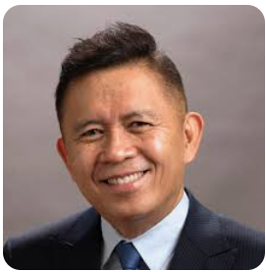  1. Discuss strategies for reimagining healthcare delivery to expand access, reduce disparities, and improve outcomes, with a focus on advances in congenital heart defect care.  2. Analyze how innovations in care models and technology can enhance early diagnosis, treatment, and long-term management of congenital heart defects across diverse and underserved populations.
  Disclosure
  Slides
8:20 | Opening Pathways: Expanding Access to Curative Therapies for Neuropathies and Peripheral Nerve Disorders  Eric E. Floranda, M.D.  It is my pleasure to introduce Dr. Eric Floranda, Chairman of Neurology at Bon Secours St. Francis Medical Center and Medical Director of the Neurodiagnostic Laboratory for Bon Secours Neurology in Richmond, Virginia. Dr. Floranda completed his neurology residency and served as chief resident at the University of Connecticut before pursuing fellowship training in Neuromuscular Medicine at the Cleveland Clinic Foundation. He is widely respected for his expertise in diagnosing and treating complex neurological disorders and for his compassionate, patient-centered approach to care. Through his clinical leadership, dedication to excellence, and commitment to improving quality of life, he has made a lasting impact on the lives of his patients and the field of neurology. Please join me in welcoming Dr. Floranda.  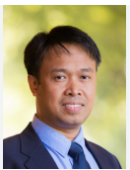  1. Review recent advances in curative therapies for neuropathies and peripheral nerve disorders, and explain their clinical implications for patient care.  2. Evaluate strategies to expand patient access to these therapies, particularly in resource-limited or underserved healthcare settings.
  / | Disclosure
   | Slides
8:40 | Algorithms and Outreach: Reimagining Psychiatric Access Through Technology  Katherine M. Napalinga, M.D.  It is my pleasure to introduce Dr. Katherine Napalinga, a distinguished child and adolescent psychiatrist and Program Director of the Psychiatry Residency Training Program at Tower Health Reading Hospital in Pennsylvania. With more than 20 years of clinical experience, Dr. Napalinga completed her psychiatry residency at Einstein Medical Center Philadelphia, followed by fellowship training in Child and Adolescent Psychiatry at Hahnemann University Hospital and Drexel University College of Medicine. She is widely recognized for her expertise in autism spectrum disorder, attention-deficit/hyperactivity disorder, and mood disorders, and is deeply committed to improving the mental health and well-being of children, adolescents, and their families through compassionate, evidence-based care and education. Please join me in warmly welcoming Dr. Napalinga.  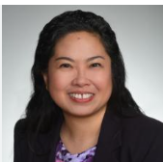  1. Describe strategies for building a smarter, fairer healthcare system by leveraging technology to expand access to psychiatric care and mental health services.  2. Analyze the role of algorithms, digital tools, and outreach initiatives in reimagining healthcare delivery models to reduce disparities and improve mental health outcomes.
  / | Disclosure
   | Slides
9:00 | Updates on Sexually Transmitted Infections in the Philippines and the Country’s Response - Gaps and Challenges  Loyd Brendan Norella, M.D.  It is my pleasure to introduce our next speaker, Dr. Loyd Brendan Norella, a leader in sexually transmitted disease prevention and public health in the Philippines. A graduate of the University of the Philippines College of Medicine, Class of 1999, Dr. Norella has dedicated his career to public health and program management. Through his work with the Pilipinas Shell Foundation, Inc. and the Global Fund-supported PROTECTS Program, he has helped expand awareness of sexually transmitted infections, improve access to testing, and strengthen linkage to care for communities across the Philippines. Please join me in welcoming Dr. Norella as he shares his insights on the future of STD prevention, diagnosis, treatment, and health equity.  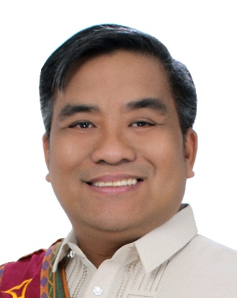  1. Describe current epidemiologic trends and emerging challenges related to sexually transmitted infections (STIs) in the Philippines, including their public health impact.  2. Identify key components of the Philippine response to STIs and HIV, including existing gaps, barriers to care, and opportunities to improve prevention, testing, treatment, and community engagement.
  / | Disclosure
  / | Slides
9:20 | Q&A Panel
9:40 | Exhibit Hall / Break
Moderator: Jennifer Co-Vu, M.D.
Session 4: Educating the Next Generation of Healthcare Leaders:
Cultivating Vision, Innovation, and Impact

10:00 | The Thinking Machine: Cultivating Innovation and Leadership in the Future of Pulmonary Medicine  Jonathan T.A. Castro, M.D.  It is my pleasure to introduce Dr. Jonathan Castro, a board-certified specialist in Pulmonary and Critical Care Medicine and a recognized leader in critical care. Dr. Castro completed his residency at Akron General Medical Center, followed by fellowship training in Pulmonary and Critical Care Medicine at the MetroHealth/Case Western Reserve University program. He also earned a master's degree in Biomedical and Health Informatics from the University of Washington. Today, he serves in several leadership roles at the Cleveland Clinic, including Staff Physician in the Critical Care Center, Medical Director of the Marymount Hospital Intensive Care Unit, and Quality Officer for the Tele-Critical Care Program. His expertise and leadership continue to advance the care of critically ill patients through innovation and excellence in critical care medicine. Please join me in warmly welcoming Dr. Castro.  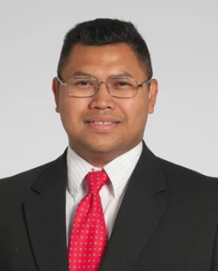  1. Describe how advances in preventive and personalized medicine, including the application of artificial intelligence, are shaping the future of pulmonary care and influencing the next generation of clinical leadership and healthcare innovation.  2. Analyze the potential of AI-driven tools to enhance early detection, risk prediction, and individualized treatment strategies in respiratory health, while exploring the leadership skills needed to guide ethical, patient-centered, and technology-enabled pulmonary care.
  Disclosure
  Slides
10:20 | Scalpels and Stewardship: Leadership in Filipino Surgical and Healthcare Training  Dione A. Parreño-Sacdalan, M.D.  It is my pleasure to introduce Dr. Marie Dione P. Sacdalan, a distinguished colorectal surgeon, educator, and academic leader from the University of the Philippines. Dr. Sacdalan completed her training in General Surgery and Colorectal Surgery at the Philippine General Hospital. She currently serves as Associate Professor in the Department of Surgery at the UP College of Medicine, Vice Chief of the Division of Colorectal Surgery, and Deputy Director for Training and Research at the Philippine General Hospital. Her clinical and research interests include colorectal cancer, perioperative nutrition, global surgery, and hereditary cancer genetics. Through her leadership in education, research, and patient care, Dr. Sacdalan continues to advance the field of colorectal surgery while mentoring the next generation of Filipino surgeons. Please join me in welcoming Dr. Sacdalan.  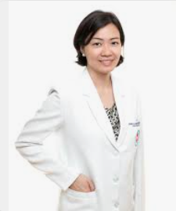  1. Describe key principles in cultivating vision, innovation, and impact among the next generation of healthcare leaders, with a focus on leadership development in Filipino surgical and healthcare training.  2. Analyze how leadership, mentorship, and stewardship can shape the future of surgical education and healthcare delivery in the Philippines and beyond.
  / | Disclosure
   | Slides
10:40 | Lighting the Path: Mentorship and Teaching for a Broader Impact in Infectious Diseases  Bernard Jonas Macatangay, M.D.  It is my pleasure to introduce Dr. Bernard Jonas "Beej" Macatangay, Chief of Infectious Diseases at the University of Pittsburgh School of Medicine and UPMC, and an internationally recognized physician-scientist in the field of HIV research. After completing his training in Internal Medicine and Infectious Diseases, Dr. Macatangay built a distinguished career in translational and clinical research focused on immune regulation, chronic inflammation, viral persistence, and innovative strategies aimed at achieving an HIV functional cure. In addition to leading the Division of Infectious Diseases, he serves as Co-Director of the ACTG Immunology Specialty Laboratory and Clinical Laboratory Director of the Pitt Clinical Research Site, where his work continues to advance our understanding of HIV, COVID-19, and other complex infectious diseases. Please join me in warmly welcoming Dr. Macatangay.  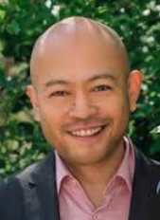  1. Describe strategies for cultivating vision, innovation, and leadership among the next generation of healthcare professionals, with an emphasis on mentorship and teaching in the field of infectious diseases.  2. Analyze how effective mentorship and education can amplify leadership development and broaden the impact of future healthcare leaders in infectious disease care and beyond.
  Disclosure
  Slides
11:00 | Beyond the Nephron: Cultivating Future Healthcare Leaders Through Vision, Innovation, and Mentorship  Brian Michael I. Cabral, M.D.  It is my pleasure to introduce Dr. Brian Cabral, a distinguished nephrologist, transplant specialist, healthcare executive, and medical educator. Dr. Cabral completed his residency in Internal Medicine at Akron General Medical Center and his fellowship in Nephrology at Northwestern University. Over the course of his career, he has become a recognized expert in kidney disease, renal transplantation, and healthcare leadership. He currently serves as Senior Vice President and Chief of Makati Life Medical Center, where he is helping shape the future of healthcare delivery while remaining actively involved in medical education, research, and public advocacy. Through his dedication to advancing kidney health and improving patient care, Dr. Cabral has made a lasting impact on both the medical profession and the communities he serves. Please join me in welcoming Dr. Cabral.  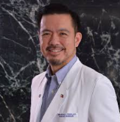  1. Explore strategies to engage and inspire Gen Z medical trainees by leveraging nephrology’s complex systems and emerging technologies as models for cultivating vision and innovation in healthcare leadership.  2. Evaluate the role of mentorship and educational innovation in shaping the next generation of healthcare leaders, with emphasis on fostering impact that extends beyond specialty boundaries.
  Disclosure
  Slides
11:20 | Gen Z in the Lecture Hall: Strategies for Teaching, Engaging, and Inspiring the Digital Generation in Medical School  Maribel Amante-Aurelio, M.D.  It is my pleasure to introduce Dr. Maribel "Bel" Aurelio, Associate Professor in the Department of Preclinical Sciences and Associate Dean of Student Affairs at St. Matthew's University School of Medicine. Dr. Aurelio completed her pediatric residency and served as Chief Resident at the University of the Philippines–Philippine General Hospital, where she conducted pioneering research on the use of virgin coconut oil to improve outcomes in premature infants. Since joining St. Matthew's University in the Cayman Islands, she has become a dedicated educator and academic leader, playing a key role in curriculum development, clinical skills training, and student mentorship. Through her commitment to academic excellence, compassionate patient care, and student wellness, Dr. Aurelio continues to inspire and prepare the next generation of physicians. Please join me in warmly welcoming Dr. Aurelio.  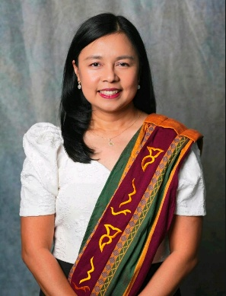  1. Identify key characteristics, values, and learning preferences of Generation Z that influence their engagement in medical education.  2. Apply evidence-based strategies to effectively teach, motivate, and connect with Gen Z learners in the medical school setting.
  / | Disclosure
  / | Slides
11:40 | Q&A Panel
12 PM | Lunch / Exhibit Hall / Adjourn General Session

